# Afbeeldingsresultaat voor fresh4cs(Non)-technical assessment of top 5 locations

Deliverable D 3.2.2

The preliminary assessment for the business cases is based on the technical and non-technical constraints identified in D 3.1.4. Data for the analysis in these deliverables became available from:

* The workshop held on March 10, 2020, on which 8 farmers were present (data on both technical and non-technical constraints)
* The interviews held with 7 farmers (data on non-technical constraints)
* The more in-depth technical assessment of Deltares of 9 parcels, held by 4 farmers: Van Cruijningen, Dieleman, Waverijn and Hereijgers. See Figure 1 for an overview of the parcels and farmers. A larger version is included in Appendix 1.

Figure 1. Overview of parcels and farmers

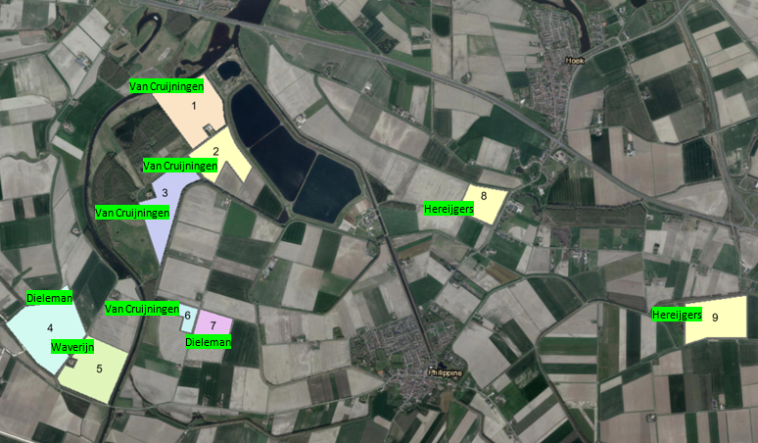

Two locations were selected for a first pilot: Parcel 1 (Van Cruijningen, Isabellaweg) and Parcel 7 (Dieleman, Kruisweg). This reports summarizes what decision rules informed this selection. The data informing the decisions is summarized in Tables 1,2 and 3.

Table 1 Data of the parcels of Van Cruijningen

|  |  |  |  |  |  |  |  |  |
| --- | --- | --- | --- | --- | --- | --- | --- | --- |
| **Criteria** | **Farmer** | **Van Cruijningen** | | | | | | |
| Demographics | **Location** | Isabellaweg (Parcel 1) | Dijkmeesterpolder (Parcel 6) | | | Braakmanbossen (Parcel 2 ) | Braakmanbossen (Parcel 3 ) | |
| **Coordinates** | 51.304389, 3.724919 | 51.286630, 3.721449 | | | 51.304389, 3.724919 | 51.296976, 3.721943 | |
| **Size of parcel (ha)** | 26.5 | 10.3 | | | 55 | | |
| **Crops (including last year)** | Seed potatoes, sugar beets, chicory, onions, flax and wheat. | | | | Wheat, beets, chicory, flax and seed potatoes. | | |
| **Current measures** | Two deep drains, considering to install six more. | | | | Sprinkling irrigation from basins Evides. | | |
| Socieconomic criteria | **Ultimate cost price water** | < €0,50/m3 | | | | < €0,12/m3 (Price of Evides or industrial water) | | |
| **Interest in pilot** | Great | | | | Great | | |
| **Attitude towards collaboration with other farmers** | Open | | | | Open | | |
| **Existing collaborations** | None | | | | Neighbouring farmers and Evides. | | |
| **Driver for collaboration** | Higher earnings/yield of crops and learning. | | | | Control of water level and (sprinkling) irrigation. | | |
| **Desirable outcomes pilot** | Water and increased earnings. | | | | Increased earnings. | | |
| **Amount of (extra) water needed** | 50-100 mm/ha = 5000-10000 m3? (depends on duration of drought). | | | | 55 ha surface water irrigation. | | |
| **Criteria for collaboration (1)** | Contingency plan and emergency measures for flooding. | | | | Quality of the water. | | |
| **Criteria for collaboration (2)** | Fits in current investment plan of infrastructure. | | | | Clarity on requirements of industry. | | |
| **Criteria for collaboration (3)** | Figuring out potential legal and insurance-related issues. | | | |  | | |
| Technical criteria | **Ground level >1.6 m NAP** |  | |  |  | | |  |
| **Size freshwater lens >15 m** |  | |  |  | | |  |
| **>5 m sand under freshwater lens** |  | |  |  | | |  |
| **Freshwater lens in >70% sand** |  | |  |  | | |  |
| **<3 m clay at the top of subsoil** |  | |  |  | | |  |
| **Size of unsaturated zone winter > 1 m** |  | |  |  | | |  |
| **Area with natural infiltration** |  | |  |  | | |  |
| Distance to source | **Indication of cost** | 50m | | 300m | 70m | | | 20m |

Table 2 Data of the parcels of Dieleman and Waverijn

|  |  |  |  |  |  |  |  |  |
| --- | --- | --- | --- | --- | --- | --- | --- | --- |
| **Criteria** | **Farmer** | **Dieleman** | | | **Hereijgers** | | | |
| Demographics | **Location** | Spanjaardsweg 2 (Parcel 4) | de Kruisweg (Parcel 7) | | | Axelsegatweg 42 (Parcel 8) | Visartpolderdijk (Parcel 9) | |
| **Coordinates** | 51.285586, 3.706876 | 51.285807, 3.731488 | | | 51.296775, 3.768724 | 51.287191, 3.803696 | |
| **Size of parcel (ha)** | 40 | 10 | | | 10 | 16 | |
| **Crops (including last year)** | Potatoes, onions, carrots, chicory, wheat and grass seeds. | | | | Onions and carrots. | | |
| **Current measures** | Deep drain. | | | | None, considering to install two deep drains. | | |
| Socio-economic criteria | **Ultimate cost price water** | Nothing because of own deep drain, only if salinization occurs. | | | | Depends on the availability of water, added value at 10 bar supply. | | |
| **Interest in pilot** | Great | | | | Great | | |
| **Attitude towards collaboration with other farmers** | Open | | | | Open | | |
| **Existing collaborations** | Waverijn | | | | Meijer | | |
| **Driver for collaboration** | Certainty of freshwater (for parcel at Spanjaardsweg). | | | | Unkown | | |
| **Desirable outcomes pilot** | Water and increased earnings. | | | | Water | | |
| **Amount of (extra) water needed** | Strongly depends on weather. | | | | 9500 m3/year in a dry summer. | | |
| **Criteria for collaboration (1)** | No sudden changes in water level. | | | | Clear plan and approach with more information about installation. | | |
| **Criteria for collaboration (2)** | Sustainable solution for Dow and farmers. | | | | Partcipation should be binding. | | |
| **Criteria for collaboration (3)** | Trust in each other. | | | |  | | |
| Technical criteria | **Ground level >1.6 m NAP** |  | |  |  | | |  |
| **Size freshwater lens >15 m** |  | |  |  | | |  |
| **>5 m sand under freshwater lens** |  | |  |  | | |  |
| **Freshwater lens in >70% sand** |  | |  |  | | |  |
| **<3 m clay at the top of subsoil** |  | |  |  | | |  |
| **Size of unsaturated zone winter > 1 m** |  | |  |  | | |  |
| **Area with natural infiltration** |  | |  |  | | |  |
| Distance to source | **Indication of cost** | 480 | | 650 | 1.900 m | | | 4.300 m |

|  |  |  |
| --- | --- | --- |
| **Criteria** | **Farmer** | **Waverijn** |
| Demographics | **Location** | Spanjaardsweg 1 (Parcel 5) | |
| **Coordinates** | 51.281290, 3.711461 | |
| **Size of parcel (ha)** |  | |
| **Crops (including last year)** | Wheat, potatoes, onions and carrots. | |
| **Current measures** | Normal drainage, groundwater is too salty for deep drains. | |
| Socio-economic criteria | **Ultimate cost price water** | Ultimate price of €0,02/m3 | |
| **Interest in pilot** | Great | |
| **Attitude towards collaboration with other farmers** | Open | |
| **Existing collaborations** | Dieleman | |
| **Driver for collaboration** | Access to freshwater in aquifer storage. | |
| **Desirable outcomes pilot** | Water | |
| **Amount of (extra) water needed** | 60 mm/ha = 6000 m3? (for potatoes). | |
| **Criteria for collaboration (1)** | Clarity on purpose and distribution arrangements. | |
| **Criteria for collaboration (2)** | Price should not be high. | |
| **Criteria for collaboration (3)** |  | |
| Technical criteria | **Ground level >1.6 m NAP** |  |
| **Size freshwater lens >15 m** |  |
| **>5 m sand under freshwater lens** |  |
| **Freshwater lens in >70% sand** |  |
| **<3 m clay at the top of subsoil** |  |
| **Size of unsaturated zone winter > 1 m** |  |
| **Area with natural infiltration** |  |
| Distance to source | **Indication of cost** | 15m |

## Decision rules.

The selection was based on 5 decision rules.

1. Willingness to cooperate with Dow and with others. The willingness to cooperate with Dow and others in the future was seen as a prerequisite for selection, and therefore a *necessary* condition. At this point in the project the farmers’ commitment to the project concerns above all the pilot. Uncertainties regarding the organisation and cost of large-scale operations are too high for more long-term commitments to large-scale operations to the project. **Conclusions:** Van Cruijningen (parcel 1,2,3 and 6), Dieleman (parcel 4 and 7), Waverijn (parcel 5) and Hereijgers (parcel 8 and 9) all expressed interest to participate in the project and were open to share information. Two other farmers present at the workshop, De Meijer and Mol, displayed lesser interest and are therefore not included in the analysis.

2. All technical criteria are met, or do not pose a problem for the pilot. The locations were evaluated on 7 criteria. According to the notes of Deltares a thickness of more than 5m sand under freshwater lens (technical criterion 3 in the tables) does not pose a strong threat and was therefore allowed. Preferred candidates are labelled with green or orange colors in the Tables. **Conclusions:** parcels 2, 3 and 6 of Van Cruijningen and 7 of Dielemanmeet all of the criteria, parcel 1 of Van Cruijningen meets 6 criteria. All of these parcels were considered preferred candidates.

3. Variation of owners. In order to mitigate the risk that the project delays seriously because of famers abandoning the project, it is preferred to start with locations of at least two different farmers. **Conclusions:** Parcel 7 of Dieleman at Kruisweg should be included together with one of the three parcels of van Cruijningen.

4. Distance / high level cost estimate. Investment cost is largely determined by the cost for piping. This in turn is determined by the distance to a suitable fresh water source and available infrastructure. This cost is estimated at 250 euro per meter piping. **Conclusions:** Isabellaweg, parcel 1, is close to basin Evides and has a direct connection to the basin. It is therefore preferred over parcel 6 which is 300m from the nearest source and parcel 2, that although is near to the ditch is a less preferred location by Van Cruijningen. Kruisweg is close to Evides ditch.

5. Geographical spread in order to have an outlook on future large scale implementation. Parcels should not be too closely located. With a large spread between the parcels, the potential to enlarge the scale by including parcels located between the initially selected parcels is maximized. **Conclusions:** parcel 1 and 7 offer the opportunity to enlarge the scale of operations with parcels 2 and 3 of van Cruijningen

Appendix 1 MAP

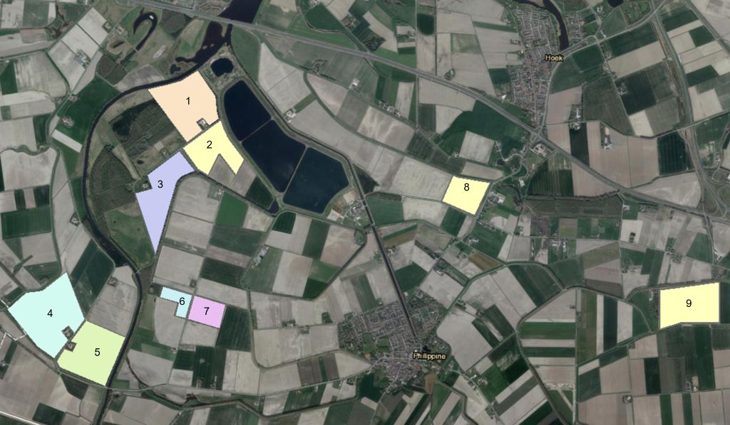

Van Cruijningen

Van Cruijningen

Van Cruijningen

Van Cruijningen

Dieleman

Dieleman

Waverijn

Hereijgers

Hereijgers